### IoT-BASED EV SMART PARKING AND GREEN CHARGING SYSTEM

##### A PROJECT REPORT

***Submitted by***

**KUSHAL SINGH [Reg No: RA1911003030129] ANMOL MADDHESHIYA [Reg No: RA1911003030140] SIDDHARTH SINGH [Reg No: RA1911003030148] SATYAM KUMAR [Reg No: RA1911003030158]**

*Under the guidance of*

#### Nishant Anand

(Asst. Professor, Department of Computer Sciene & Engineering)

***in partial fulfillment for the award of the degree of***

##### BACHELOR OF TECHNOLOGY

in

#### COMPUTER SCIENCE & ENGINEERING

of

##### FACULTY OF ENGINEERING AND TECHNOLOGY



###### S.R.M. NCR Campus, Modinagar, Ghaziabad

**SRM INSTITUTE OF SCIENCE & TECHNOLOGY**

(Under Section 3 of UGC Act, 1956)

#### BONAFIDE CERTIFICATE

Certified that this project report is titled “**IoT-BASED EV SMART PARKING AND GREEN CHARGING SYSTEM”** is the bonafide work of **KUSHAL SINGH[Reg No:RA1911003030129] ,ANMOL MADDHESHIYA [Reg No:RA1911003030140] ,SIDDHARTH SINGH [RegNo:RA1911003030148],**

###### **SATYAM KUMAR [Reg No:RA1911003030158]** who carried out the project work under my supervision. Certified further, that to the best of my knowledge the work reported herein does not form any other project report or dissertation on the basis of which a degree or award was conferred on an earlier occasion on this or any other candidate.

**SIGNATURE**

Nishant Anand

**GUIDE**

Asst. Professor

Dept. of Computer Science & Engineering

Signature of the Internal Examiner

**SIGNATURE**

Dr. R.P.Mahapatra

**HEAD OF THE DEPARTMENT**

Dept. of Computer Science & Engineering

Signature of the External Examiner

### ABSTRACT

###### The development and growth of electric vehicles(EVs) have increased several folds during the last 10 years. EVs are a green and sustainable alternative to LPG and diesel vehicles that pollute and threaten the environment, especially for CO2 reduction and alternative energy uses. Due to the increasing popularity of EVs nowadays there is an increased demand for charging stations. Additionally, parking cars has always been a difficult chore. Consequently, EV also needs a reliable parking system. Our current project entails "Smart Parking as well as Green Charging system of EV”. We are using the Node MCU, Arduino UNO, Servomotor, and 6 IR sensors to develop an IOT-based car parking system. For a hassle-free parking system, we leverage the Internet of Things (IoT) and getting the information on Blynk application about the slot availability. The 2nd part of the project deals with the challenge of charging the EVs using a 15Vsolar panel that would be used to charge a 12V battery which rests on the platform where the designated car is parked.

**ACKNOWLEDGEMENTS**

I would like to express my deepest gratitude to my guide, Nishant Anand Assistant Professor his valuable guidance, consistent encouragement, personal caring, timely help and providing me with an excellent atmosphere for doing research. All through the work, in spite of his busy schedule, he has extended cheerful and cordial support to me for completing this research work.

**-Kushal Singh**

**-Anmol Maddheshiya**

**-Siddharth Singh**

**-Satyam Kumar**

|  |  |
| --- | --- |
| **Table of Contents** | **Page No.** |
| Declaration | 2 |
| Acknowledgement | 3 |
| Abstract | 4 |
| List of Tables | 7 |
| List of Figures | 8 |
| Chapter 1: Introduction | 9 |
| 1.1 Overview | 9 |
| 1.2 Literature Survey | 12 |
| 1.3 Need Analysis | 18 |
| 1.4 Aim | 20 |
| 1.5 Problem Formulation | 21 |
| 1.6 Objectives | 22 |
| 1.7 Deliverables | 22 |
| 1.8 Novelty | 23 |
| Chapter 2: Theory, Standards and Constraints | 24 |
| 2.1 Overview | 24 |
| 2.2 Working Principle | 24 |
| 2.3 Assumptions and Constraints | 27 |
| 2.4 Technical Standards | 27 |
| Chapter 3: Design Methodology | 28 |
| 3.1 Proposed Workflow | 28 |
| 3.2 Flowchart | 29 |
| 3.3 Simulation Design | 30 |
| 3.4 Hardware Working | 31 |
| 3.5 RFID Code | 35 |
| Chapter 4: Results and Discussion | 40 |
| 4.1 Simulation Results | 40 |

* 1. Serial Monitor Output 41
  2. Schematic Diagram 42
  3. Hardware Results 43
  4. Discussions and Inferences Drawn 44
  5. Justification of Objectives Achieved 44

Chapter 5: Conclusion and Future Work 46

* 1. Conclusion 46
  2. Future Work 47

Chapter 6: Project Metrics 48

* 1. Challenges Faced and Troubleshooting 48
  2. Relevant Subject and Interdisciplinary Aspect 49
  3. Components Used 49
  4. Work Schedule 54
  5. A to K Mapping 57
  6. Team Assessment Matrix 58

References 59

Progress Reports 62

Daily Dairy 72

Plagiarism Report 77

Annexures 78

List of Student Outcomes 79

**LIST OF TABLES**

|  |  |  |
| --- | --- | --- |
| Table | Caption | Page No |
| Table 2.1 | Working of Project | 26 |
| Table 6.1 | A To K Mapping | 57 |
| Table 6.2 | Team Assessment Matrix | 58 |

**LIST OF FIGURES**

|  |  |  |
| --- | --- | --- |
| Figure No. | Caption | Page No. |
| Fig. 1.1 | Cloud Based Parking System | 14 |
| Fig. 1.2 | Flowchart of Methodology | 15 |
| Fig. 2.1 | IoT Cloud | 26 |
| Fig. 3.1 | Payment Gateway | 28 |
| Fig. 3.2 | Block Diagram | 29 |
| Fig. 3.3 | Methodology | 29 |
| Fig. 3.4 | Simulation Design | 30 |
| Fig. 3.5 | Hardware View | 33 |
| Fig. 3.6 | Hardware View | 33 |
| Fig. 3.7 | Hardware View | 27 |
| Fig. 4.1 | Tinker CAD Design-1 | 40 |
| Fig. 4.2 | Tinker CAD Design-2 | 41 |
| Fig. 4.3 | Proteus Simulation Design | 42 |
| Fig. 4.4 | Hardware View | 43 |
| Fig. 6.1 | NodeMCU | 50 |
| Fig. 6.2 | IR Sensor | 51 |
| Fig. 6.3 | RFID Card | 52 |
| Fig. 6.4 | Arduino R3 | 52 |
| Fig. 6.5 | Jumper Wires | 53 |
| Fig. 6.6 | Servo Motor | 53 |
| Fig. 6.7 | 16x2 LCD Display | 54 |

**CHAPTER-1 INTRODUCTION**

* 1. **Overview**

The idea of smart parking was put forth to address the issue of parking availability and management in megacities. Due to the increasing number of vehicles on the road and the limited supply of parking spaces, there is no way to avoid vehicle congestion. Driver hostility and environmental pollution would result from this congestion. Finding a spare parking space is nearly impossible during peak hours when the flow density is at its highest, and these conditions may get worse.

The simplest strategy is to give a route with a specific destination instruction inside the parking garage. Smart parking technology shows a visible result of an accessible parking spot as opposed to having the driver drive around aimlessly. The driver scans the line of ascending LED lighting and colour.

Red and yellow are the two primary colours used to denote occupied and free space, respectively. The driver looks up, follows the set of LEDs, and looks at the Yellow LED that is located at the ceiling of each parking space. When a vehicle is detected, This lighting is automatically controlled by sensors, and the results are communicated with the aid of the LED's colour. This gadget not only makes things more accessible but also manages traffic to shorten wait times.

The internet of things was first introduced in 1999. at the self-ID centre, Kevin Ashton used it for the first time. With the advancement of this most recent burning technology, everything in our environment will be able to communicate with one another while requiring less human interaction.

The internet of things is still in its early stages, and there is no established standard architecture. All relevant fields are currently conducting numerous studies and implementations. As a result,

there are no rules or limitations that specify what constitutes the internet of things. Therefore, the definition of an application of the internet of things varies depending on the context.

It can be summed up by saying that objects that are present in the real world or in an environment are wired or wirelessly connected to a network and have sensors or other embedded devices attached to them. These related items are known as smart tools or smart objects. It also includes machines with intelligence and communication, the outside world, & various different things.

Additionally, it includes ways to connect any two machines, including those that connect machines to people and people to machines, or M-M communication. As the technology advances, several standardisation organisations have worked on M-M communication-related projects, including the Open Mobile Alliance (OMA), European Telecommunication Standards Institute (ETSI), Institute of Electrical and Electronic Engineers (IEEE), and 3rd Generation Partnership Project (3GPP) organisation.

The use of transceivers, sensors, actuators, microcontrollers, and other communication devices simplifies daily tasks. One of the key advantages of the internet of things is the ability to track behaviour. Other advantages include improved situational awareness, sensor-driven analytics for decision making, quick response, etc. IOT technology is developing across a range of intelligent application domains, but its limits are still undefined. These include applications for grids, lighting, energy, cities, and health that are all "smart”.

It is currently putting these technologies into practice. Sensing, processing, and connectivity are three broad classifications of this. Sensing, on the other hand, entails determining variables like temperature, pressure, and the speed of moving objects like cars, people, or any other object (accelerometer). And a variety of processors, such as, these can be processed by network processors, MCU/MPU hybrids processors, etc. Additionally, various technologies, including GPS, Wi-Fi, BT/BTLE, RFID, and, are used to connect devices. Majority of people on the planet reside in urban areas. Therefore, the cities are fully occupied.

As more people utilize cars for transportation, there are a lot more cars available for people's convenience. Most of the time is spent by people looking for parking spots to leave their cars

in. Because of the resulting traffic, finding a parking spot for their car becomes a challenging task. Only congested roads in urban areas experience heavy traffic, which causes people to waste time looking for parking spaces in odd places. Our solution uses a Parking space that can be found using a Raspberry Pi-based parking sensor and a pi-camera, which then sends the information to a server where it is stored and later accessed by users.

This makes it easier for the user to check the status and availability of parking spaces prior to leaving on a trip. Here, the challenge is to make the best use of the available resources in order to cut down on search times and city traffic. Some embedded systems, including the Arduino, Raspberry Pi, Tsgate, Tsmote, and others, are used to develop IoT applications. We aim to design a system with lower costs and higher performance. A few existing parking systems use sensors to collect data, but since sensors, like video sensors, are expensive, our goal is to design a system that does so more affordably.

When the first mention of the internet of things in 1999 at the autoID centre, Kevin Ashton used it for the first time. With the advancement of this most recent burning technology, everything in our environment will be able to communicate with one another while requiring less human interaction.

There is currently no established standard architecture for the internet of things because it is only in the beginning stages. As a result, there are no rules or limitations that define what the term "internet of things'' means. As a result, the definition of the internet of things depends on the context and application. It can be summed up by saying that objects that are found in the real world or in an environment are embedded with sensors or other systems and connected to networks using wired or wireless connections. These connected devices are referred to as smart devices or smart objects.

It also includes intelligent machines that communicate with one another, their surroundings, and other objects. It also includes connections between any two machines, as well as between machines and people and vice versa. This exchange is known as M-M communication. Different standardisation organisations, including the Open Mobile Alliance (OMA), European Telecommunication Standards Institute (ETSI), Institute of Electrical and Electronic Engineers (IEEE), and 3rd Generation Partnership Project (3GPP) organisation, have carried out some

M-M communication-related activities as the technology develops. The use of transceivers, sensors, actuators, microcontrollers, and other communication devices simplifies daily tasks.

The ability to track behaviour is one of the internet of things' main benefits. Improved situational awareness, sensor-driven decision analytics, quick control, and responsiveness are additional benefits.

It is now implementing a number of smart applications, including those for smart grids, smart lighting, smart energy, smart cities, smart health, etc. Sensing, processing, and connectivity are three main classifications of this. While detecting includes detecting the speed of moving objects. Additionally, the devices are connected by a number of technologies including Wi-Fi, GPS, BT/BTLE, RFID, and others.

Urban areas are home to the vast majority of people on the planet. Therefore, the cities are fully occupied. There are many vehicles available for people's convenience as more people use vehicles for transportation. The majority of people's valuable time is spent looking for places to park their cars. As a result, it can be challenging for drivers to find parking spaces when there is traffic congestion. The main cause of traffic in urban areas is vehicle congestion, which causes people to waste time looking for parking spaces in unusual ways. Our system is a parking sensor built on a Raspberry Pi that uses a pi-camera to identify open parking spaces and sends that information to a server, where it is stored and accessible to users. This makes it easier for the user to check the status and availability of parking spaces prior to leaving on a trip. Here, the challenge is to make the best use of the available resources in order to cut down on search times and city traffic.

* 1. **LITERATURE SURVEY**

#### [1]

It takes a lot of energy and time to find parking, which produces high costs. In order to effectively manage and enhance resources, smart cities use modern technologies of every kind. Parking lots in cities are a valuable resource that must be managed. The smart parking management system was developed by us to manage parking and assist users in saving time, effort, and money (SPMS). In the context of contemporary life, it has become crucial to improve parking availability searches and decrease traffic jams at parking entrances. Where there is a possibility of parking issues, searching for or reserving available parking online in

advance is a preferable alternative to looking for space at a parking lot. We developed our technology-based smart parking management system to:

* + - Control parking and deal with problems well
    - Make use of technological advancements to further the concept of smart cities.

The suggested system uses a number of technologies to control parking. In addition to other essential services, users can use it to make payments, make reservations, and find parking. More advanced services have been added, such as monitoring parking conditions and receiving notifications and statistics. The system is equipped with sensors and an automatic number plate recognition (ANPR) camera to monitor occupancy and control access. The remaining sections of the essay are structured as follows.

#### [2]

Due to the dramatic increase in the quantity of vehicles while travelling & the inefficient control of the available parking area, the difficulty of navigating urban traffic is getting worse. In order to find parking spaces that are appropriate for a driver's vehicle, as well as to reduce fuel consumption and air pollution, an automated smart parking management system must be developed.

It can take almost 15 minutes to locate a parking space that will suit a driver's needs, which increases fuel use, backed-up traffic, and air pollution. There has been a lot of research done on the designing and creating smart parking systems. An inventory of some characteristics intelligent parking systems:

Parking lot management includes things like real-time route guidance and parking assistance, parking lot reservations, & vehicle occupancy detection. The majority of smart parking systems (SPS) proposed in the literature over the last few years provide answers for the design of parking availability information systems, parking reservation systems, occupancy detection and management of parking lots, real-time navigation within the parking facility, etc. However, the literature pays very little, giving real-time attention to the detection of improper parking and the automatic collection of parking fees. This paper presents an internet-of-things (IoT) based E-parking system that makes use of an integrated component known as a parking metre to address the issues listed below (PM).

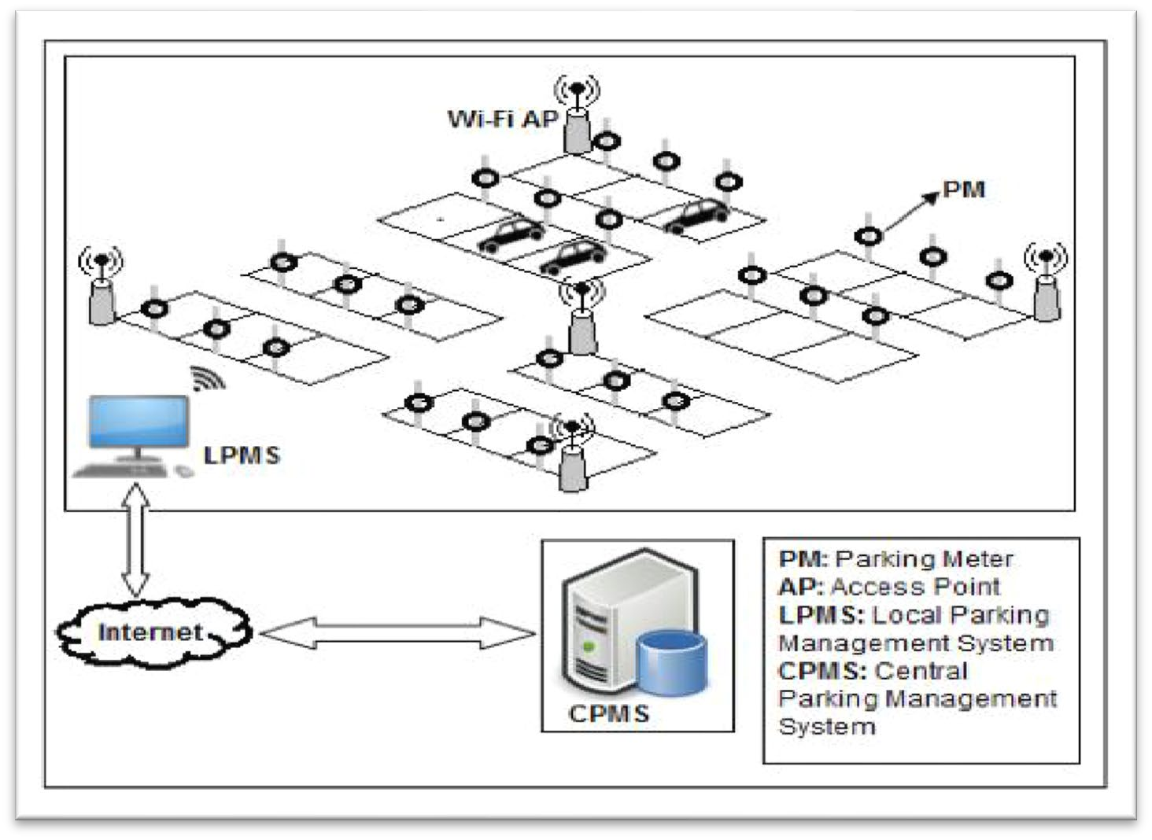Additionally, the E-parking system suggested in this paper known as parking meter (PM) based E-parking, offers a smart parking management programme for the entire city by providing a parking lot and information on the availability of parking facilities reservation system. It also detects improper parking in real-time, predicts how long each vehicle will be parked, and automatically collects parking fees (PM-EP)

**Fig. 1.1 Cloud Based Parking System**

#### [3]

India is becoming more motorised, or more people own private vehicles than use public transportation. The demand for parking spaces to store cars grows along with the percentage of people who own cars.

However, the situation right now is that there aren't enough parking spaces available, or it's possible that people aren't yet aware of the permitted parking spaces in their neighbourhood. This situation causes an unnecessary overcrowding of vehicles on the road and makes it difficult for people to cross the street. We are putting forward an Android application that is multilingual and will help people find parking spaces online as a way to solve the aforementioned issues. Digitally means that the system will assign the user's desired parking space based on his or her convenience and the user's current location.

Digital payments or payments made at vending machines are both acceptable. After the user registers and logs in with his or her account, the system will be able to locate the user's location and display the closest parking area and available parking spaces. If not, the user will be directed to the slot that is the next closest, and so on.

The current system includes both conventional and application-based parking strategy The manual method of parking is used in the traditional method, which requires the user to travel great distances and pay additional fees in order to find a parking space.

Applications that, for example, provide parking spaces for a specific locality comprise an application-based approach. The "Parking Panda" app offers parking spaces to venues like stadiums and sporting events.

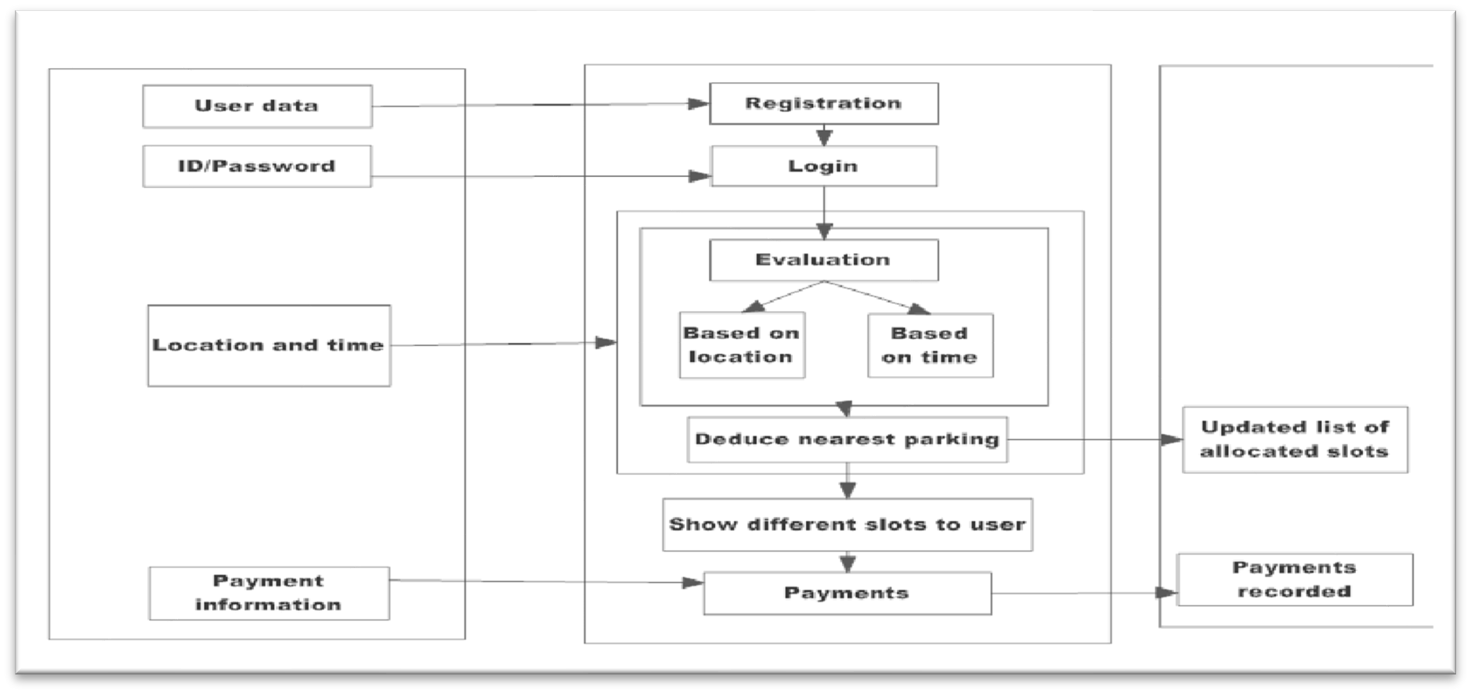

**Fig. 1.2 Flowchart of Methodology**

#### [4]

The key to any nation's success is its transportation system. Many people today have the choice to travel by using their own vehicle. The demand for goods will undoubtedly rise as a result, but "parking" is one of the issues brought on by increased traffic. It has become problematic to park cars in the major metropolises because doing so is a tedious and difficult task.

The implementation of improved and more shrewd parking management mechanisms is the subject of extensive research and development worldwide. Parking requires a central web server, an embedded web server, and a wireless sensor network module. The parking space's

condition is tracked using infrared (IR) sensor nodes in sensor networks, which then send the information to an embedded web server. As a result, user can use the data shown on an LED screen to check for open vehicle slots.

The users are not guided by these systems to the parking lot. Drivers will begin looking for another slot if the one they originally wanted is not available, adding another parking space will make this process time-consuming and worsen traffic congestion.

This paper proposes a reservation-based smart parking system that enables users to reserve parking spaces in advance via a mobile application, thereby reducing traffic congestion. The vehicle parking issues should be resolved effectively and affordably thanks to this application. The user's mobile device needs to have the application installed. Our proposal uses client-server architecture, which is different from the current system in that the client requests that slots be reserved and the server replies with the slots that are open at that moment. The user can select the parking space that best suits his or her needs using our system.

The advantage of this is that it will take the car much less time to find a parking space. The user also has the option of using more sophisticated payment methods like an e-wallet, debit card, or credit card. A penalty will be added for late exit and overusing the slot after the user- specified entry and exit times. On cancellation of a parking space and an early departure, a refund will be issued. The supervisor must keep an eye on the area.

Many of the car parking facilities are becoming overwhelmed by the rise in the number of vehicles on the roads and in parking lots. The present-day wireless sensors or smart parking systems Network Parking requires a central web server, an embedded web server, and a wireless sensor network module. The parking space's condition is tracked using infrared (IR) sensor nodes in sensor networks, which then send the information to an embedded web server.

As a result, the user can use the data shown on an LED screen to check for open vehicle slots. In order to ensure that there are no open spaces, image-capture, devices are used to continuously photograph the parking lot, resulting in high power usage and high maintenance costs. Some systems available on the market use wireless sensor networks and wireless sensors to efficiently locate parking spaces, such as smart parking services. It is not practical to add extra hardware to the car in order to use this system, though.

Parking spots can be extremely hard to find in a crowded city. People frequently find that a parking lot is full and that there are no open spots when they arrive. Then they have to drive around in their car once more to find a parking space.

#### [5]

New technologies are currently revolutionising the parking sector, enabling cities to significantly reduce congestion levels. Sensor networks that detect vehicle occupancy give smart parking systems their fundamental intelligence. It is now possible to find available parking spaces in real-time and help drivers get where they need to go with the help of smart parking technology.

A variety of vehicle detectors have been used to collect parking information. The most popular kinds of vehicle detectors are inductive loops, acoustic sensors, infrared sensors, and ultrasonic sensors. Information collection in the field of vehicle parking has been proposed using a system utilising video camera sensor technologies. However, inclement weather and night-time operation can damage a video camera sensor.

It is also expensive and generates a large amount of data, which can be difficult to transmit over a wireless network. The most popular technique is using wireless area networks and magneto-resistive-based detection systems, networks because of their high accuracy. The potential for electromagnetic interference, which lowers accuracy, and the need for constant data collection, which depletes batteries, are just a few of the issues that this type of sensor has. It has been suggested that a parking sensor system would improve the accuracy of vehicle detection and lengthen battery life.

While energy efficiency has been optimised using power management techniques, a two-fold sensing approach yields high occupancy monitoring accuracy. There are several Signal Strength Indicator (RSSI) techniques that are dark and measurement-based.

The wireless sensors, which are either stuck to the surface of every parking lot or buried in the pavement, are still bothersome. Existing sensors, like Parking lot-specific ground-based sensors can cost up to $200. Because many sensor units are needed to cover the entire parking lot, smart parking technology that uses wireless sensors for outdoor parking is expensive. Despite significant advancements in parking occupancy monitoring systems, the field of smart parking payment research is still in its infancy.

However, there are companies working on patents for parking payment systems. The first technique involves using a camera or an RFID transceiver to find and identify vehicles. A disadvantage of this solution is how difficult and expensive it is to implement when a detection device is placed in each parking lot. When only an RFID transceiver is used for vehicle detection and identification, electromagnetic interference may also reduce the system's accuracy. Furthermore, even though data on empty parking lots is unavailable, this system is designed to detect a vehicle as it pulls into a space and demands payment. When watching the parking of vehicles, it has been suggested to use two cameras to record the entrance and exit of a vehicle.

A method and system for compiling and displaying information on parking spaces is also covered in. The user puts the ID into a parking meter or a smartphone app on his smartphone and makes the parking payment when he parks in a spot identified by an individual ID.

After processing the data, the database uses the parking spaces ID to change the status from unpaid to paid. How many parking spaces are occupied is determined using these details. In this paper, we suggest a smart sensor system for monitoring and paying for outdoor parking without requiring user or driver input. To be deployed, it won't be necessary to upgrade the components in every parking lot. The sensor has advantages for reliable payment and detection, lower costs due to an easier installation process and system design, and longer battery life due to the system's reduced power consumption.

* 1. **Need Analysis**

The advanced technology of a smart parking system is its most significant advantage. In order to guarantee successful results, it adheres to the most recent technologies and ideas. Smart parking is very simple to oversee and manage in terms of both design and implementation. Because of its well-organized structure, staff members can manage this system with ease.

Both the Cloud and the Internet of Things computing have significantly evolved. Each technology has benefits of its own, but their integration is anticipated to have a number of additional advantages. One the one hand, by utilising the boundless potential and resources of the Cloud, IoT can overcome its technological constraints, such as those pertaining to storage, processing, and energy. But by utilising IoT, the cloud can also broaden the scope of its application to deal with real-world entities in a more distributed and dynamic manner.

The Cloud essentially acts as a middleman between things and applications, disguising all the complexity and functionalities needed for an application to function. The Internet of Things and cloud computing were combined for the following reasons. Capacity for storage: The Internet of Things (IoT) is a network of numerous information sources (things) that collectively produce vast quantities of unstructured or semi-structured data.

Massive amounts of data must be gathered, accessed, processed, visualised, and shared in order to support IoT. The cloud offers unlimited, affordable, It is the best and most economical option due to its on-demand storage capability, & way to manage the data derived from IoT. Through common APIs, users can access and visualise data stored in the cloud from anywhere. Processing speed: The IoT devices currently in use have a processing speed.

Information obtained from various more sensors are sent to powerful nodes for processing and aggregation. The use of the Cloud's limitless processing power and on-demand model can meet the computation requirements of the Internet of Things. IoT systems could process data in real- time with the aid of cloud computing, enabling highly responsive applications. x Resources for communication.

The core purpose of the Internet of Things is to enable interoperability between IP-enabled devices using a specific set of hardware. Cloud computing enables the connection, tracking, and management of devices over the internet from any location. by utilising integrated applications IoT systems could remotely manage and monitor objects in real-time. Scalability: The cloud provides an IoT strategy that is scalable. It permits the dynamic growth or decrease of resources. There could be a plethora of "things" added to, removed within the system if integrating the cloud was made possible. The demands of objects and applications are taken into account when allocating resources in the cloud.

Accessibility: With cloud integration, resource accessibility at any time and from any location is made very simple. Many cloud service providers guarantee 5-9 availability. Applications run continuously in the cloud, and users get ongoing services. Interoperability: A variety of different device types are used in the Internet of Things. Compatibility problems may arise as a result of the different hardware or software configurations of these devices.

In an IoT environment, ensuring interoperability between these devices becomes very challenging. Because it provides a common platform for connecting and communicating between different devices, the cloud aids in solving this issue. Data sharing and exchange are permitted between devices in a format that works for them.

There are several angles to consider the problem of parking management, including the volume of traffic on the roads, according to recent studies in big cities. Drivers have troublesome issues when attempting to put their vehicles in parking spaces since it is difficult locating a parking spot.

Drivers wasting time & effort looking for parking spaces and ultimately parking their cars on the street, the parking lot becomes even more crowded. In the worst case scenario, it becomes impossible for people to find a parking space, especially during busy times and the holiday season. Congestion and parking in large cities are two of the most significant issues.

As a result, managing the garage through the internet of things is effective when automated parking system management is used. In order to assist users in finding available parking spaces, smart parking is a technological solution that makes use of sensors and information technology. Some of the most well-liked types of data routing, intelligent payment, and other smart parking systems are all computerised parking lots. For these classes, parking availability must be made known. When a user registers with the system, a special identification number is generated for him.

When the user makes a reservation, the system has the reservation information. The system building is composed of three levels: the lowest level deals with sensing functions; the middle level creates data transmission; and the upper level manages information storage and processing as well as user interfaces.

The current environment exhibits both an excess of cars and a difficulty managing them in the right order. As population growth is accompanied by higher utilisation rates, keeping up with the population becomes more challenging. Anywhere in the world, finding a place to park our car is a constant struggle.

It becomes challenging to find a spot when parking in shopping centres, multistorey IT structures centres, plus parking lots with a large number of parked vehicles. On side streets & interior lanes, this task seems simple.

* 1. **AIM**

Design and Implementation of Smart Parking System

* 1. **Objective of Smart Parking**

Utilizing low-cost sensors, real-time data, and applications that track available and unavailable parking spaces are all part of smart parking. To reduce the manually consuming time looking to find the best parking level, location, or even lot, the procedure will be automatic. Some solutions will offer a comprehensive selection of services, such as online payments, reminders when parking permits are about to expire, and even the ability to search for specific vehicles in very large parking lots. A parking solution can benefit both the lot's user and proprietor.

* **Improved parking** – Users save time, money, and effort by locating the best parking spot that is open. The parking lot quickly fills up, allowing businesses to use the available space efficiently.
* **Reduced traffic**: Traffic flow increases as fewer vehicles are required to search for available parking spaces.
* **Pollution reduction** - Locating parking burns almost a million barrels of oil every day. The amount of daily car emissions will be reduced thanks to an ideal parking solution, which will also result in a significant reduction in travel time and eventually, global environmental pollution.
* **Increased Security** - Security guards and parking lot staff have access to current lot information that can help stop parking infractions and strange behaviour. Relevant information can be gathered by cameras that can read licence plates. Furthermore, checks on the street can get more relevant film if there is less street traffic. Additionally, fewer people hunting for parking spots on the streets can lessen accidents as a result of parking's diversion.
* **Management costs -** Lower costs and higher automation reduce labour costs and resource exhaustion.
* **Improved User Experience** - Every element of the user experience will be included in a single activity with a smart parking system. The steps in the process of getting to the

destination include paying the driver, conducting location searches, identifying specific locations, and receiving time alerts.

* 1. **Problem Formulation**

According to recent studies in large cities, there are several ways to look at the issue of parking management, including the amount of traffic on the roads. Due to the difficulty in finding a parking space, this causes bothersome problems for the drivers when trying to park their cars.

The parking lot becomes even more crowded as a result of drivers spending time and energy looking for parking spaces but ultimately leaving their cars parked on the street. In the worst case, finding a parking spot is impossible, particularly during rush hour, busy times and the holiday season.

* 1. **Expected Deliverables**

The main important benefit of a smart parking system is its advanced technology. In order to guarantee successful results, it adheres to the most recent technology and ideas. Smart parking is simple to oversee and manage in terms of both design and implementation. Because of its well-organized structure, staff members can manage this system with ease.

This system can provide users with parking information, but it is unable to indicate which parking spaces are available and occupied. As a result, the system is unable to handle the problem intelligently. Corporate offices, movie theatres, shopping centres, IT hubs, and other places can install this system. In many public locations, the system only displays the availability and is unable to display the precise slot and route to the slot that is open. Therefore, it is necessary to deftly locate the route to the open space.

* 1. **Novelty of Work**

This type of project can help various ways like:

* It will help the consumer to find the empty slot easily.
* It reduces the time to search for the empty slot thereby preventing aimless search of free slots.
* It even helps in reducing fuel consumption.
* This system provides high security
* It reduces labour as the whole system is automated.
* It will be useful in parking areas where capacity is more than 1000 like cinemas, airports, shopping malls, IT Hubs, Offices etc.